## **Tic-Tac-Toe**

**Program Description:**

Create a program which allows the user to play multiple games of Tic-Tac-Toe. The program should tell who wins as well as give a running total of the number of wins a person has accumulated. The A goes towards whoever can create a better game (animation, graphics etc.)

**Rubric:**

**“B”**

- running total - who wins - plays multiple games

**“A”**

-properly Disable form -ai -animation; flashing lines - graphics

**Sample output:**

1. Gui before any input: 2. Gui while game is being played:

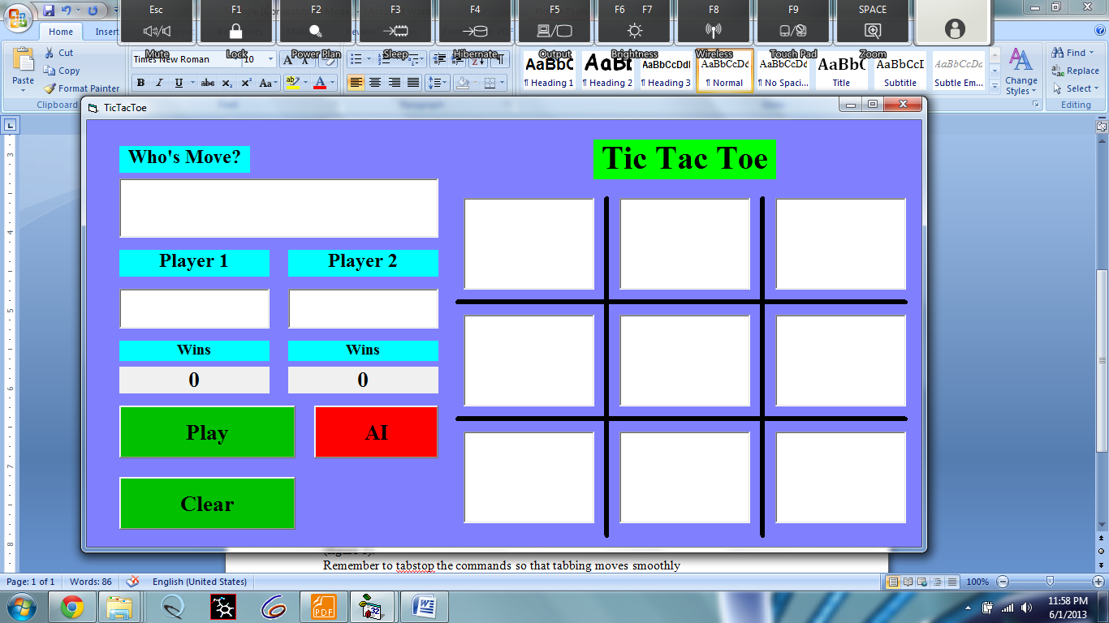 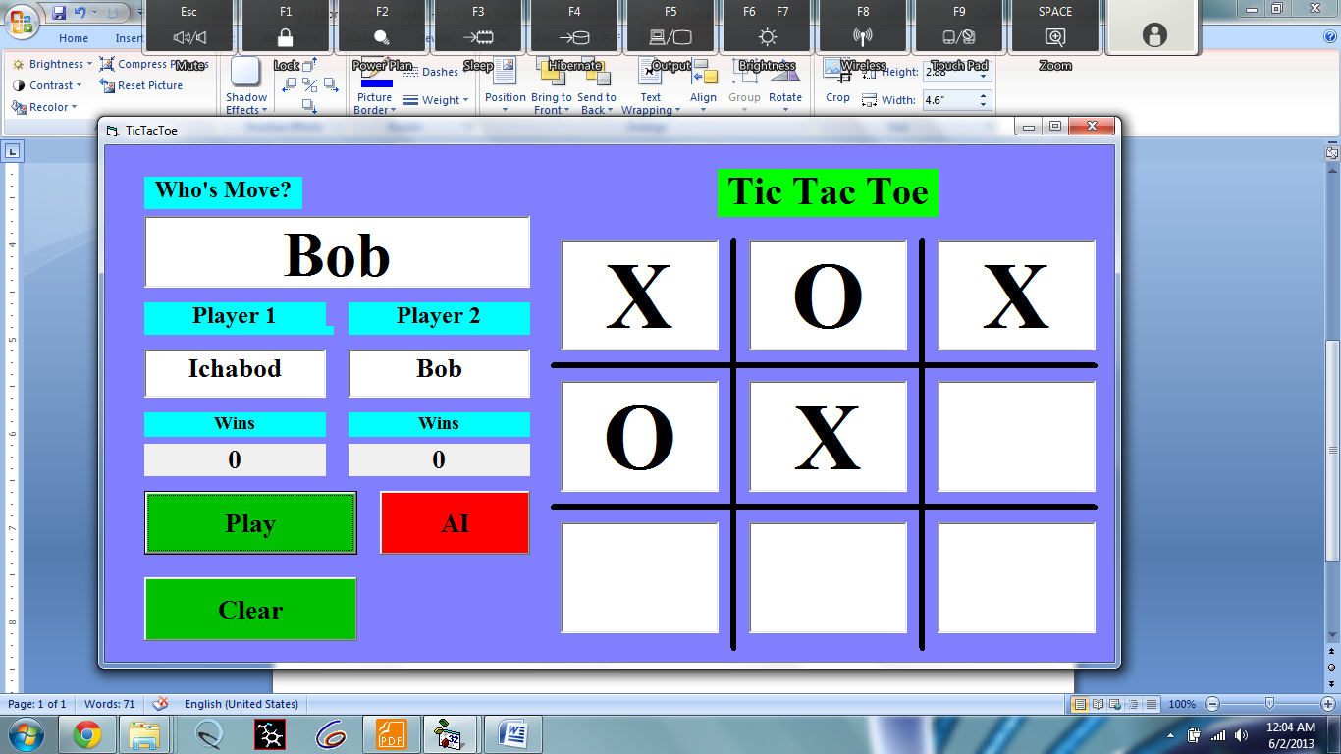

3. Gui at end of game: * 4. Gui if rematch is played:*

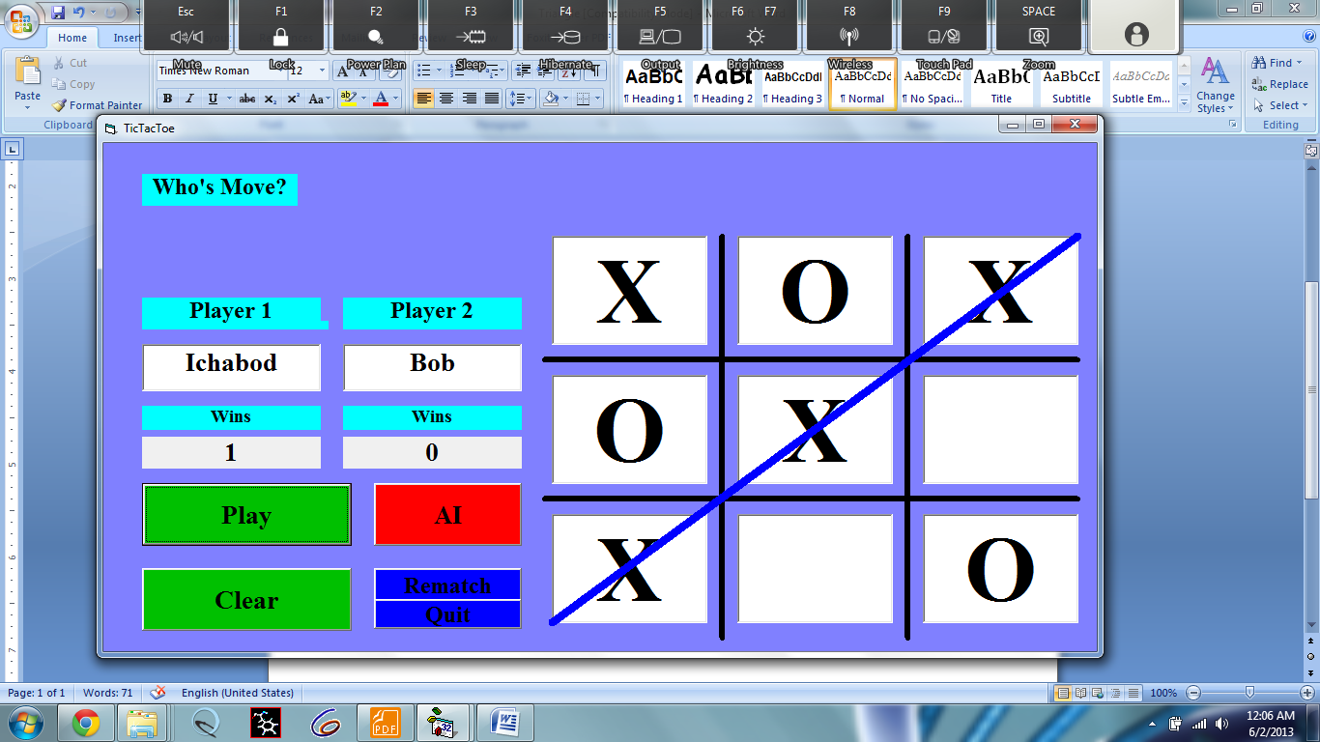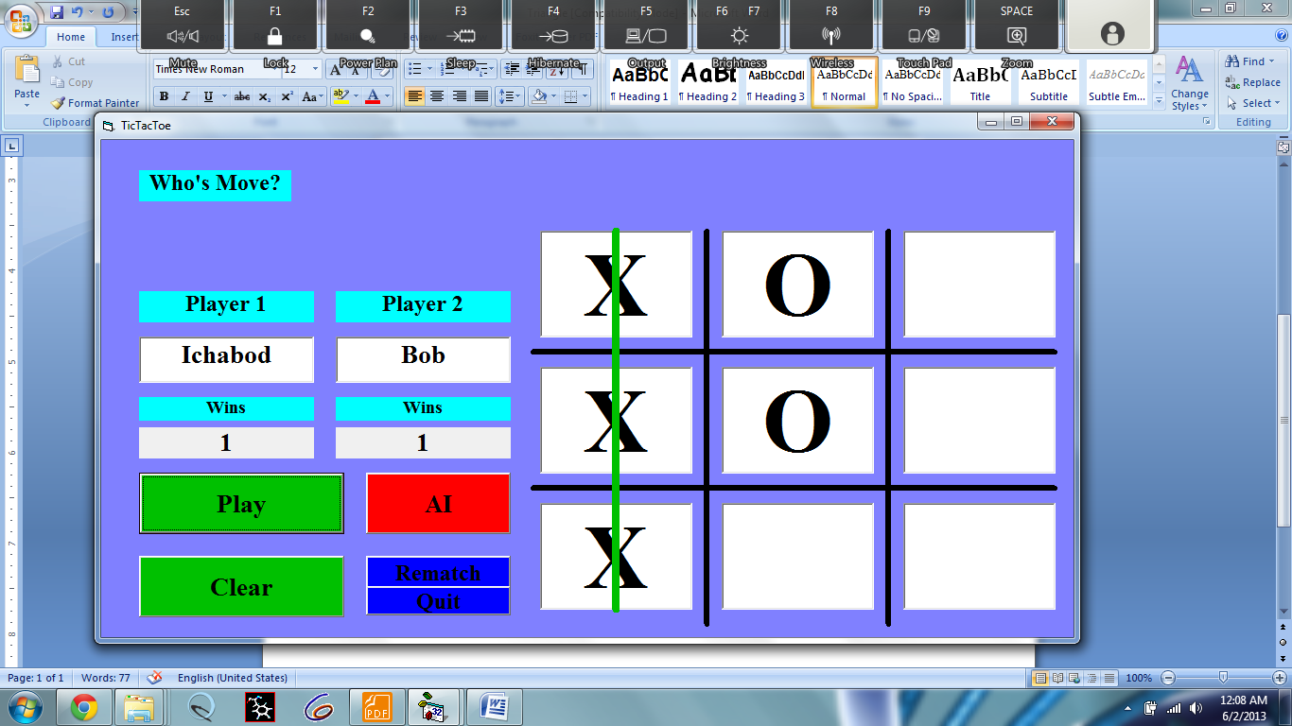

If clear is pressed the program should go back to the way it was in figure 1.

Notice that in figure 4 Ichabod’s win is still kept

* Who’s move and Tic Tac Toe label boxes don’t show because they are flashing when the game is played